Nutanix 1.1 As-Built Documentation ReadMe

NOTE: This script requires PowerShell V3 or later.
NOTE: Word 2007 is not supported.
New Script Features
- Complied into .exe binary
- Optimized code for faster runtime.
- New table function that now utilizes native word tables.

Bugfixes
- No reported bugs as of version 1.1

This version of the script will gather and format the following information:
- Cluster Overview
- Licensing
- Node Information
- Storage Pool(s)
- Containers
- vDisks
- VMs
- Protection Domain

Prerequisites
Before we can start using this program to document your Nutanix environment, lets ensure we have the necessary requirements.
  - Install the PowerShell cmdlets from the PRISM interface as shown in Figure 1.
Figure 1
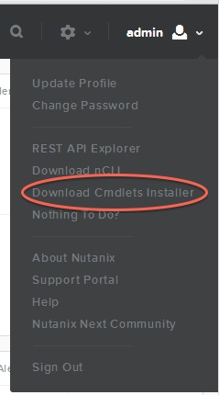

Program Usage
How to use this program?
  - Save the executable as Nutanix_As-Built_Documentation_v1_1.exe to your preferred folder.
  - Run Nutanix_As-Built_Documentation_v1_1.exe -IP 1.1.1.1 -User Admin -Password **** and press Enter.
  - Run Nutanix_As-Built_Documentation_v1_1.exe -IP 1.1.1.1 -User Admin -Password **** -full and press Enter if you want a full report of your Nutanix Cluster.
  - By default, a Microsoft Word document is created
- If you use the –PDF option, a PDF file is created

